# Experiment No: 8

# Title: Development of different timer Applications.

**Date: /12/2021**

**Name: Shaunak Deshpande**

**Class: TY IC-C**

**Roll number: 39**

**GR Number: 11911180**

1. **Develop and simulate IL for Boolean logic gates. AND, OR, NOT, NAND, NOR, XOR.**

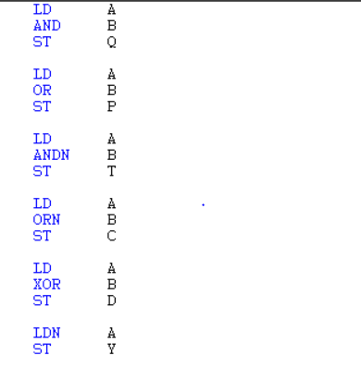

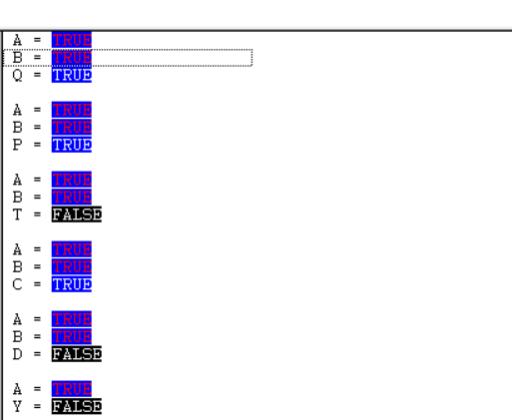

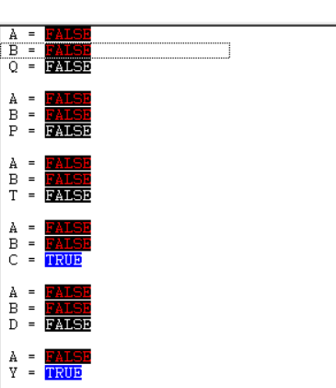

**2)When a start button is on after the delay of 10 seconds start the lamp. Implement IL for the same.**

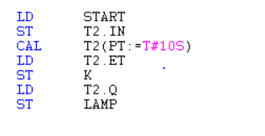

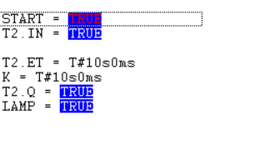

**3)Develop IL for bottle filling application.**

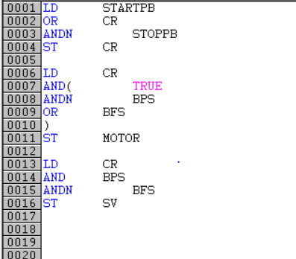

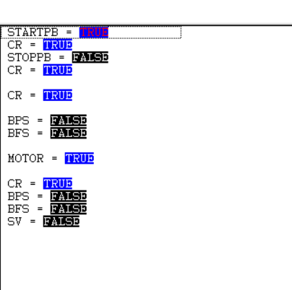

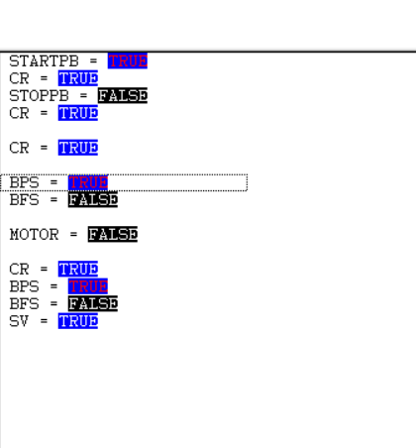

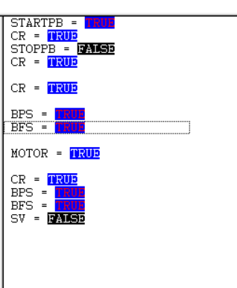

1. **Develop IL for batch reactor-**

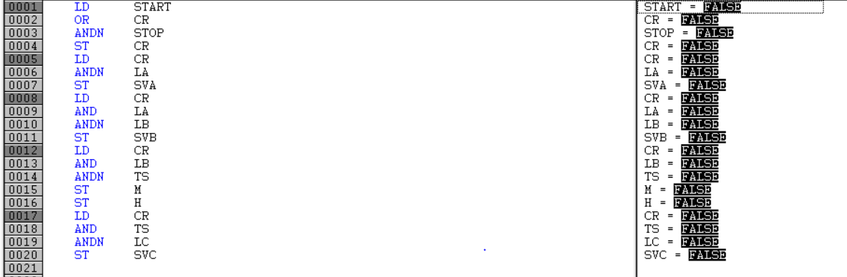

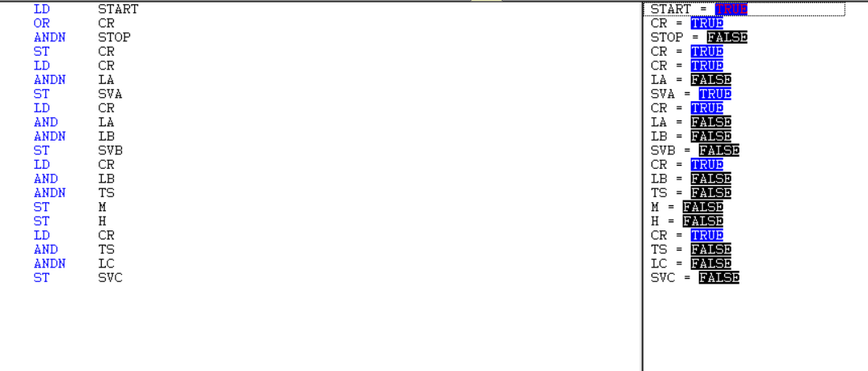

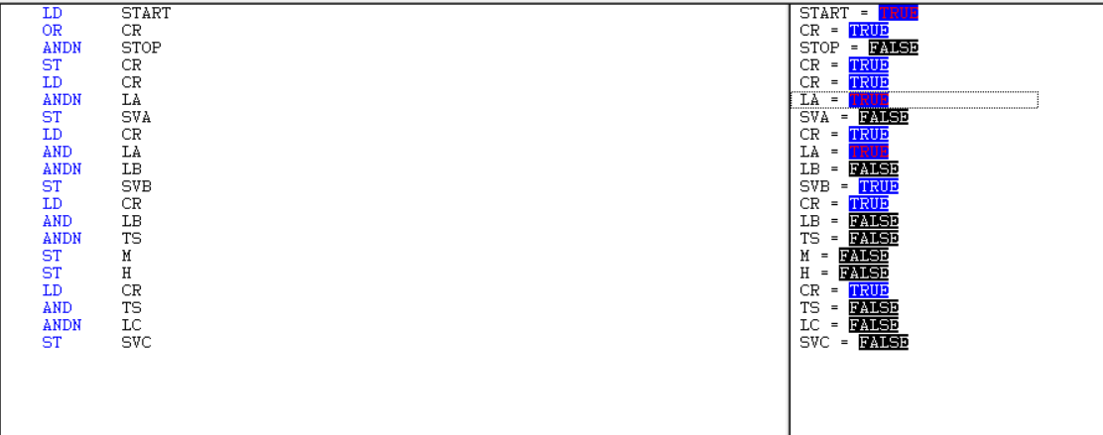

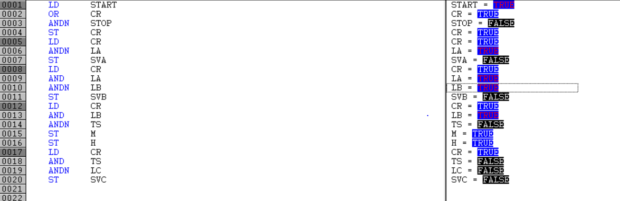

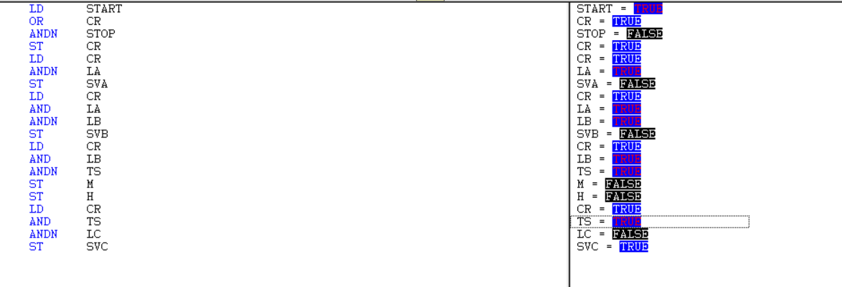

**Conclusion-**

Applications like Boolean logic gates, TON timer, Bottle filling machine and batch reactor have been developed and simulated in IL programming.